
LESSON NOTE | DETAILED EXPLANATORY NOTES
NEUROSCIENCE & AI
SENSORY RECEPTORS & NEURONAL CIRCUITS
GRADE 12 - BIOLOGY
■ ■ ■

How the Body Senses the World
To respond to the world, the body must first detect what is happening around it and inside it. This is the job of sensory receptors - specialised cells or nerve endings that pick up stimuli such as light, sound, heat, pressure and chemicals, and convert them into nerve impulses. Those impulses then travel through neuronal circuits - organised pathways of connected neurons - that process the information before a response is made.
This lesson looks at the main types of sensory receptors, how a receptor converts a stimulus into an impulse (transduction), and how neurons are wired into circuits (such as convergence and divergence) that let the nervous system combine and spread information. It builds directly on the general design of the nervous system.
Why This Matters
- Receptors are the body's detectors - the start of every response.
- Transduction turns real-world stimuli into signals the brain can use.
- Circuits let the nervous system process and combine information.
- These ideas underpin the senses, reflexes, and even robotic sensors.
Sensory Receptors & Neuronal Circuits
Key Learning Outcomes
By the end of this lesson, students should be able to:
- Define a sensory receptor and list the main types.
- Explain sensory transduction - turning a stimulus into an impulse.
- Explain the ideas of threshold, sensory adaptation and coding of intensity.
- Describe simple neuronal circuits - convergence and divergence.
- Relate receptors and circuits to the senses and to robotics.
Types of Sensory Receptors
Sensory receptors are usually classified by the kind of stimulus they detect:
- Mechanoreceptors - respond to mechanical forces: touch, pressure, stretch, sound and movement.
- Thermoreceptors - respond to temperature (hot and cold).
- Photoreceptors - respond to light (the rods and cones in the eye).
- Chemoreceptors - respond to chemicals (taste, smell, blood CO₂).
- Nociceptors - respond to pain - tissue damage or extreme stimuli.
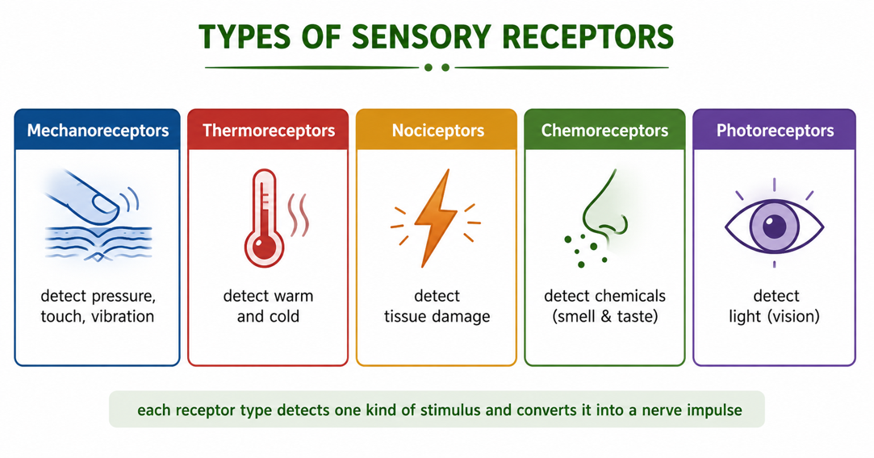
Figure 1: The main types of sensory receptor, each detecting a particular kind of stimulus.
Terminologies and Concepts
Useful terms for this topic:
- Sensory receptor: a cell or nerve ending that detects a stimulus.
- Stimulus: a detectable change (light, sound, heat, chemical, pressure).
- Transduction: converting a stimulus into an electrical nerve impulse.
- Threshold: the minimum strength of stimulus needed to trigger an impulse.
- Sensory adaptation: a receptor's response fading when a stimulus stays constant.
- Neuronal circuit: an organised group of connected neurons that processes signals.
- Convergence / divergence: many neurons feeding one, or one feeding many.
Sensory Transduction - Turning a Stimulus into a Signal
A receptor's key job is transduction: changing the energy of a stimulus (light, sound, heat) into the electrical energy of a nerve impulse. When a stimulus is strong enough to reach the threshold, it triggers an impulse that travels along a sensory neuron to the CNS, where it is interpreted. If the stimulus is stronger, the receptor fires impulses more often - this is how the nervous system codes intensity (a bright light or loud sound produces more frequent impulses). If a stimulus stays constant, many receptors show adaptation and respond less, which is why you stop noticing clothes on your skin.
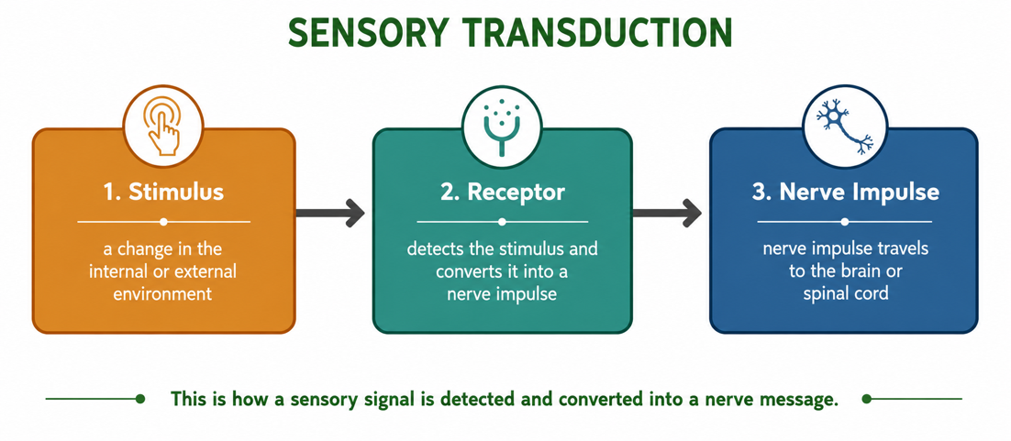
Figure 2: Sensory transduction - a receptor converts a stimulus into a nerve impulse sent to the CNS.
Neuronal Circuits - Wiring Neurons Together
Neurons rarely act alone; they are connected into circuits that process information. Two basic patterns are important. In convergence, many neurons feed signals into a single neuron, so their inputs are added together - this lets weak signals combine, or many receptors influence one response. In divergence, a single neuron passes its signal to many neurons, so one input can spread out and affect several targets at once. Real circuits combine these patterns to filter, amplify and route signals through the nervous system.
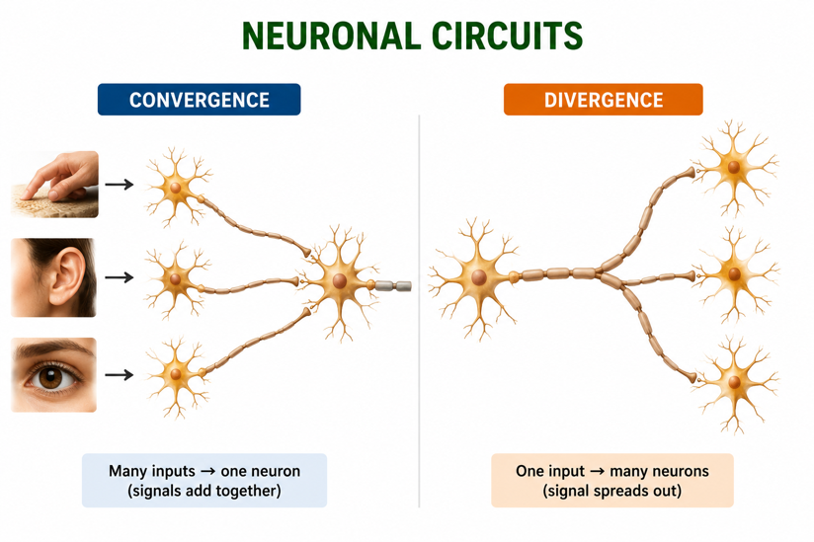
Figure 3: Two basic neuronal circuits - convergence (many to one) and divergence (one to many).
The Reflex Arc - A Simple Circuit in Action
A reflex arc is the simplest useful circuit. A receptor detects a stimulus (such as a pin prick); a sensory neuron carries the signal to the spinal cord; an interneuron relays it; a motor neuron carries the command to a muscle (the effector), which pulls the hand away. Because the signal acts through the spinal cord without waiting for the brain, the response is extremely fast - protecting the body from harm. The reflex arc shows how receptors and circuits work together to turn a stimulus into a rapid response.
Why This Matters
- The senses - receptors and circuits are the basis of sight, hearing, taste, smell and touch.
- Protection - reflex circuits give fast, automatic responses to danger.
- Medicine - testing reflexes and sensation helps diagnose nerve problems.
- Robotics - artificial sensors and circuits copy these biological designs.
PNG Context Example
Sensory receptors matter for everyday life and health in Papua New Guinea. Pain receptors (nociceptors) warn of injury or infection; thermoreceptors help the body cope with the tropical heat; and chemoreceptors for taste and smell help detect spoiled food. Some diseases and toxins interfere with sensation - for example, leprosy damages nerves and reduces the sense of touch and pain, leading to unnoticed injuries, while some snakebite venoms block nerve signalling. Understanding receptors and circuits helps explain these effects and why protecting sensation is important.
References & Related Documents
Source Documents
- STEM Biology Syllabus - Grade 12. Thema: Neurophysiology; Module: Sensory Receptors and Neuronal Circuits. Department of Education, PNG.
- Biology Standards-Based Syllabus, Grades 11 & 12 (PNG SBC 2020) - Strand 2: Life; investigate how sense organs detect stimuli and how the nervous system processes and responds to them.
Further Reading & References
- OpenStax Biology - Sensory Systems; Types of Sensory Receptors; Transduction. https://openstax.org/books/biology
- Khan Academy - Sensory perception and receptors. https://www.khanacademy.org/science/biology/human-biology

